WELCOME TO FREEDOM LEADER TRAINING

WHAT IS DELIVERANCE?
Deliverance is the process of bringing someone out of slavery or bondage. It can be either physical (external) or spiritual (internal).

Exodus opens by describing how the Hebrews were in bondage (enslaved) in Egypt. We read in Exodus 3:7-10 that Moses was God’s appointed deliverer of the Hebrew people. They were led away from bondage. God instructed them to live as a free people with access to Him. Unfortunately, they struggled to experience that freedom.

Spiritual deliverance is the process of someone being freed from bondage to the enemy.

BONDAGE TO THE ENEMY
Bondage (slavery) to the enemy happens when we live in:
sin ⏺ unforgiveness ⏺ believing lies
An evil man is held captive by his own sins; they are ropes which catch and hold him. PROVERBS 5:22

I tell you the truth, everyone who sins is a slave of sin. JOHN 8:34

When we live in patterns of sin, unforgiveness, and believing lies, even when we are blind to those patterns, we give the enemy territory and ultimately permission to affect or harm us. Both spiritual footholds and strongholds open the door for demonization.

Foothold | Temporary “in” for the enemy to disrupt our obedience  EPHESIANS 4:27
Stronghold | A sin fortress that gives domain and control to the enemy. A dangerous spiritual condition.  2 CORINTHIANS 10:4
Demonization | Any activity by the enemy or demons aimed at
distracting, influencing, traumatizing, tormenting, controlling, or destroying a person. JOHN 10:10
The enemy wants to keep us in bondage. He wants to keep his territory within us and uses condemnation and shame to his advantage.

Condemnation → Shame → Despair → Bondage

Jesus is the only one who can deliver us from spiritual bondage. He is the only one who can break the power of sin and death. He is the only one who can break the cycle of condemnation and bondage.

The Freedom experience at Lifepoint provides an intentional path to encounter the Holy Spirit and experience the true freedom Jesus offers in common areas of struggle.

The Holy Spirit does the work of freedom.
- Reveals what He wants to heal
- Identifies and draws up the roots of bondage
- Fills and empowers to hold on to the freedom gained

As Christians, God empowers us to overcome the enemy's attacks and oppression. The Holy Spirit offers us His alternative. He seeks to heal us and draw us near through:

Conviction → Repentance → Forgiveness → Freedom

In His kindness, He gives us powerful tools that the enemy and spiritual footholds and strongholds cannot withstand.

Surrender  Repentance | Forgiveness  Renouncing Lies | The Presence of the  Holy Spirit

Freedom Group Experience
For eight weeks, you will disciple and model to participants how to listen to and respond to the Holy Spirit.
- Hear the Holy Spirit for themselves
- Lean on Jesus and the truth of God’s Word
- Discuss with others the key Scriptural ideas in the curriculum
- Prepare participants for the Freedom Conference
- Live out their freedom after the group and conference

Freedom Conference
- Exposes the enemy's activity in different areas of our lives
- Healing opportunities as the Holy Spirit reveals
- Prayer in partnership with the Holy Spirit to break free from bondage
- Bless and fill them with God’s Word and promises

Freedom is Discipleship
Freedom is a vital part of discipleship at Lifepoint Church. Understanding where people are in their spiritual journey with Jesus is a key aspect of shepherding and discipleship.

You might not know, or not know very well, the people in your Freedom group. Connecting with your group members early is essential so you can lead them well.

Your first step will be a phone conversation with your new participants.
- Help them become more comfortable with you ● Check in on some Freedom readiness markers
- Verify availability for the Freedom Conference date

Freedom Timing
Freedom is a great option for most people, but the timing is also essential.
- Not well suited to a brand-new believer or someone who is very inexperienced in their walk
- Not their first (or second) small group study
- Not for people who are dealing with an overwhelming life crisis
- Active relationship with Jesus
- Some foundation of God’s Word
- Some understanding of the Holy Spirit
- Prayer is part of their life

Please reach out to participants as they sign up for your group to understand their readiness for Freedom, guide them effectively, and find out if they are available to attend the conference.

Here are some questions to ask:
- Is this your first time attending a small group?
- Do you have a relationship with Jesus? How long have you followed Him?
- Tell me more about your Bible and prayer time.
- Are you familiar with the Holy Spirit?
- Are you currently experiencing anything especially burdensome in your life right now? (verifying they're not in crisis)
- Are you available to attend the Freedom Conference on [date]?

If they are inexperienced in their walk with Jesus or don’t have a foundation for their faith, lovingly suggest that their next step may not be Freedom, but a different small group may be a more beneficial option. Freedom is for everyone, but having a foundation in God’s Word and your faith makes Freedom a better experience.

Please verify that they can attend the conference. If they aren’t sure or can’t, please encourage them by saying something like, “Freedom Conference is half of your experience, and it’s best to experience the same semester you go through the study. We ask that if you’re unable to attend the conference, please consider attending in a future semester.”

THE PATTERNS WITHIN FREEDOM

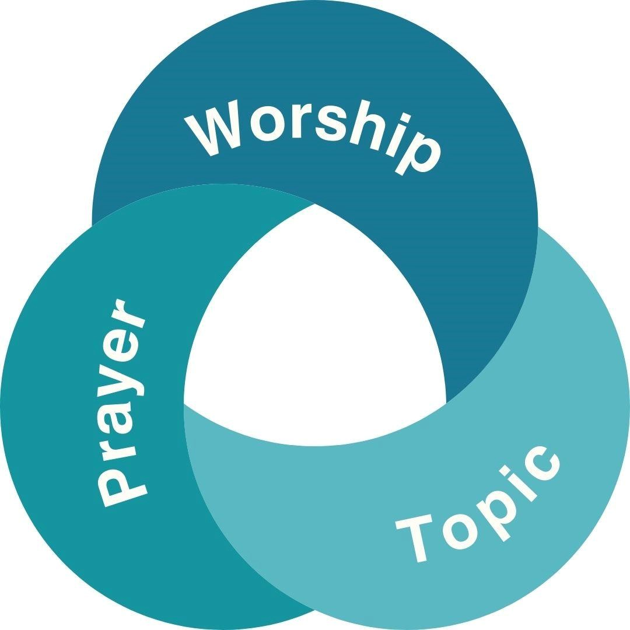

Individual time with Jesus.
Each week during your group time.
Sessions at the conference.

Why is it important?
- Consistency helps to bring structure to a process that can feel messy inside.
- Familiar patterns at the conference can reduce fear.
- A routine that creates lifelong learning habits with Jesus.

WEEKLY PARTICIPANT GROUP EXPERIENCE

WORSHIP ● | Starts the group on time
● | 8-10 minutes
TOPIC ● | Stays on the topic of the week
● | Where participants discuss what they are learning
INDIVIDUAL ●  PRAYER ● | Brief 3-5 minutes  Required before dismissal


Begin every discussion
Begin every individual prayer time

INDIVIDUAL PRAYER
Individual prayer is on-topic, short, and required.
3-5 minutes per participant.
At the conference, we keep prayers to about three minutes per participant.
What you do in your group helps prepare the participant.

What is the format?
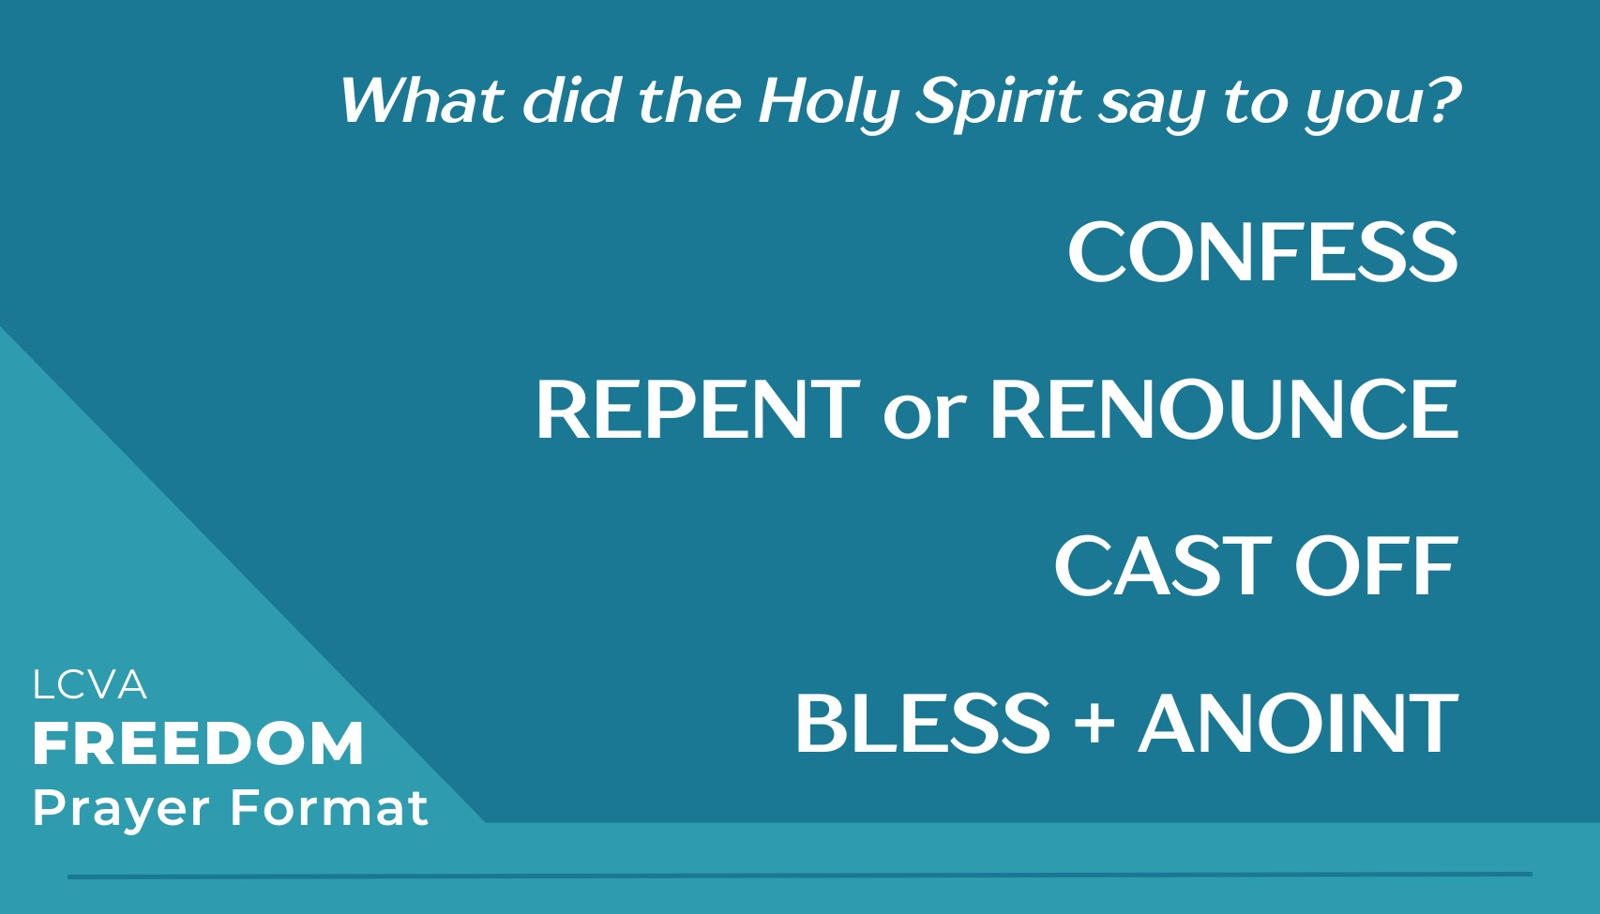

Confession happens when they share what the Holy Spirit is showing them.

Repenting is when a change of direction is needed, turning from sin toward Jesus.

Renouncing is when someone gives up or releases something. They come out of agreement with believing the lies of the enemy.

Casting off is exercising Christ's authority over the enemy's efforts in the issue being prayed about (as needed).

Blessing is inviting the Holy Spirit to fill this space in the participant that the enemy had affected. We fill the space with the Holy Spirit when something is removed.

Bless them by speaking in the opposite Spirit of the issue being prayed for.
Pride → Humility
Rejection → Acceptance
Shame → Dignity
Perversion → Purity
Words of Death → Words of Life
Hardness → Softening (not breaking)

You can also pray Scripture and who they are becoming in Jesus.

Anoint with oil.
Why are we anointing?
- The Bible states it symbolizes being healed, cleansed, sealed, and set apart.
- We do this at the conference as well.
- Please use the oil the church provides.

Gradually Train the Participant to Pray
In the first few weeks we model the prayer. They start with confessing, and we model praying through the remaining parts of the format.

By week 6, they begin to pray for themselves. We encourage them to “put the prayer in their own words.” Disciple them into doing the first three parts independently.
We bless, fill, and anoint every prayer time.

Why are we discipling participants in this format?
- Engages their will and participation
- THEY listen to the Holy Spirit
- Fruitful conference prayers
Men pray with men; women pray with women.

Do NOT pray in your prayer language with the participant.
Always ask for permission to touch the participant.

Play worship music in the background (using a speaker if possible) for privacy.

PRAYER TIPS:
- Pray standing up!
- Leaders and apprentices can split up to pray for participants.
- Keep your eyes open when you pray.
- Ask good questions to stay on topic.
- Politely interrupt a participant who isn’t staying on topic.
- Be OK with the silence as you listen to the Holy Spirit.

LEADER WEEKLY EXPECTATIONS

Prepare the Spiritual Environment
Leaders & apprentices gather
15-30 minutes before participants arrive
Worship + pray for the meeting and each other, and anoint one another.
Share any pertinent updates (non-gossip)

Prepare the Meeting Environment
Refreshments  Seats set up  Tissues/pens | Distractions removed  Worship music  Doors open for fellowship

Cultivate Discipleship Conversations
Creating and holding space for processing Truth and their story with the Holy Spirit.
- Calm, peaceful environment to process
○ If someone has strong emotions, tears are okay.
- Be okay with longer pauses in conversation.
- Stay on topic. Each week, the participants are discipled on topics that will prepare them for the conference. Use the discussion questions in the Freedom Leader Guide each week to help you stay on topic.
- Gently interrupt and redirect the conversation back to the topic.

Percentage of Speaking
This is THEIR freedom journey. We guide the conversation, we don't fill it. As the group members become more comfortable with each other, they will naturally take up more discussion time.

As a leader, we serve the group by:
Shepherding healthy discipleship conversation.
Asking questions or highlighting ideas from the curriculum
Ensure that one or two people don't monopolize the conversation.
- Lead productive, healthy discipleship conversation
- Ask questions or contribute ideas related to the material
- Redirect conversations that go off topic

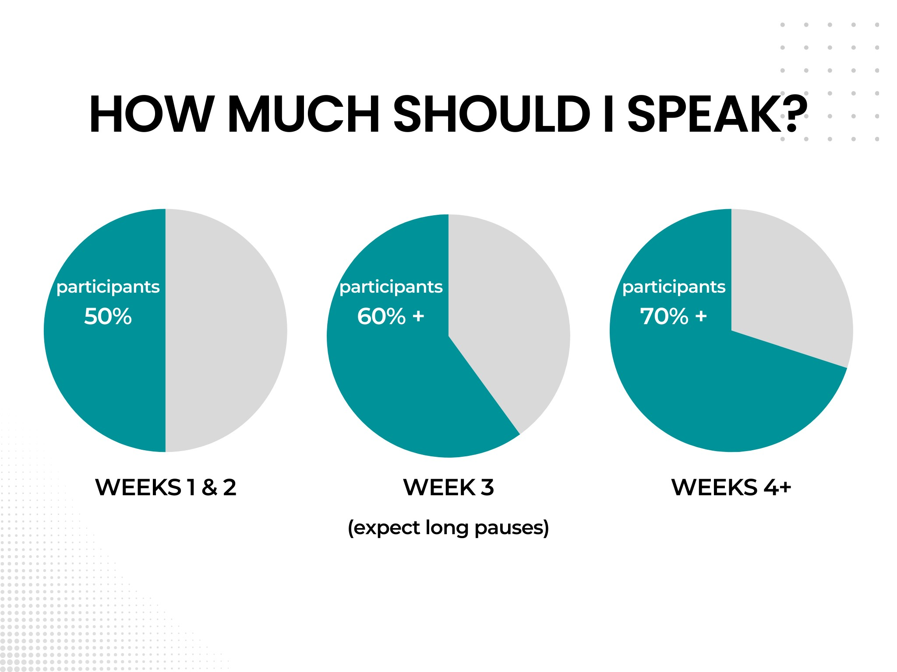

Plan Individual Prayer Time

5 min x participants = base time
5 min x 6 participants = 30 min

base time + 5 min buffer = prayer window 30 min + 5 min buffer = 35 min prayer window

End time - prayer window = end time for discussion
8:30 PM - 35 min = 7:55 PM end time for discussion

TIMEKEEPING TIPS
- Maybe set a hepatic timer on your phone or watch
- Create a worship playlist for prayer, with each song lasting 5 minutes or less

After Each Meeting

Clean up the space | Review any key dynamics (not  individual gossip)
Meet with leaders and apprentices | “Pray out”

STRUCTURE & SUPPORT
Cultivate healthy leaders and healthy groups.
Share the burden of responsibility & decision-making.
Preventing problems when negative patterns arise.

Roles & Responsibilities
COACH | Interview potential Apprentices  Quality visits 1x or more Leader Support  - Participant concerns  - Serious events  - Apprentice challenges  Help Eval Apprentices  Standard Bearer
LEADER Group shepherd
Weekly environment
Model/Example
Disciple
- Apprentices
- Participant
Prep Participant for Conference
Standard Bearer
Train apprentices into leaders
APPRENTICE | Observe/learn  Help prepare the spiritual and physical environment each week  Lead some discussions  Shadow the leader during prayer to eventually pray with participants alone

Best Practices for Group Size
- For the health of the leader and the group
- At least 2 leaders (non-apprentice) per group
- Max 5 participants per non-apprentice leader
- 8-10 participants max per group

Confidentiality
- Avoid gossiping between leaders
- Spiritual amnesia
- When/what level of detail to share with your coach

CoEd Groups
Some weeks in the Freedom curriculum are better discussed in all-male or all-female settings. Please talk with your coordinator about which weeks need to be done separately.

ALWAYS, men pray with and provide support to men; Women pray with and provide support to women.

Prayer Environment
- Semi-private spaces
- Avoid bedrooms or non-public spaces
- Worship music on well-placed speakers can be sound masking for privacy

Coach Visits
- You can anticipate your coach visiting your group at least once
- The coach and coordinator will determine the number of visits to each group.
- Immediate feedback and encouragement for leaders and apprentices
- Accountability, quality, and support
- Checking on the health of the group
○ Weekly rhythm and environment requests honored
○ Group discussion dynamics
○ Culture of honor
○ Orderly conversation
WHEN SHOULD I REACH OUT TO MY COACH?

BEFORE negative patterns develop.
When in doubt, reach out!

Leader Support
- Leader care needs
- If you feel spiritually heavy, overwhelmed, or weighed down
- Your life has new challenges that impact your ability to lead well
- If you need to combine lesson weeks in the spring semester
(scheduling or weather conflicts)
- Apprentice development

Participant Concerns
- Participant decides to leave the group.
- Participant anticipates or has 2 absences during the semester.
- Participant decides not to attend the conference.
- Participant is in crisis and needs assistance.
- Disruptive participant.
- Participant is attending Freedom “too early” in their walk/story.
- Participant calls you frequently to vent or seek advice about their situation.
- Participant seems to enjoy the attention and sympathy they receive, so they try to garner attention for their issue repeatedly.
- Participant’s emotions or circumstances are so “loud” they can’t handle the topics.
- The experience of Freedom seems too intense for them.

Safety Concerns
Someone alludes to being or confesses they are in a crisis
- Have a leader gently pause the conversation and suggest they speak 1:1 in a more private space.
- Have the co-leader continue the conversation.
- Connect with your coach immediately

FREEDOM LEADER TRAINING GUIDE

HEALTHY BOUNDARIES FOR LEADERS

Remember, their freedom is NOT our responsibility.
We are walking through a curriculum and letting God work. Galatians 5:1 and 1 Peter 5:6-7

Goals
#1 Encourage Holy Spirit dependency, NOT leader dependency. Coach them to listen to the Holy Spirit in all things.

#2 Avoid unhealthy attachment to or load on a leader.
- Mindful of discouraging emotional soul ties
- Steer away from being the center of their emotional support system

Suggestions
Communication and support boundaries help us create a gentle and appropriate relational space.

We recommend that leaders communicate as a team when participants need support for something emotionally charged or “heavy.”
(Co-ed: Men leaders communicate with men, and women leaders communicate with women.)

We suggest you respond; don’t react too quickly to urgent or emotionally charged communication.
When we react, the person/situation has control. When we respond, we are in control. Remember: We are not their life 911.

Pray first, then respond.
- Slow the pace of the response to give the Holy Spirit time to work in you and the participant.
- Use (compassionate) texts to your advantage to gain clarity, and loop in the other leader (with permission and if needed).
- After receiving clarity, schedule a time to call or meet the participant with the other leader.
- The leaders pray together first, then add the participant to the call or meet with the participant.

Honor confidentiality and avoid gossiping by inviting participants to share confidential details and updates with both leaders as needed.
14

If you are seeing some of these signs but feel unsure of the severity, your coach can help you seek the Holy Spirit’s guidance on the right next steps.

